Constructors in Python

A constructor in Python is a special method called when an object is created. Its purpose is to assign values to the data members within the class when an object is initialized. In this article, we will learn what a Python constructor is, its types, and the rules for defining constructors in Python.

**Syntax of constructor declaration :**

def __init__(self):  
 # body of the constructor

**Types of constructors :**

* **default constructor:** The default constructor is a simple constructor which doesn’t accept any arguments. Its definition has only one argument which is a reference to the instance being constructed.
* **parameterized constructor:** constructor with parameters is known as parameterized constructor. The parameterized constructor takes its first argument as a reference to the instance being constructed known as self and the rest of the arguments are provided by the programmer.

Example:-

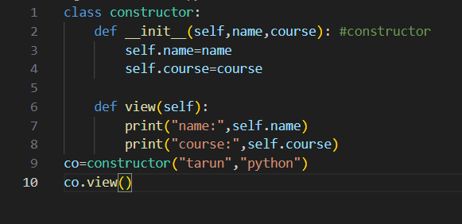

Output:-

